

***Pharmacists making medications, individually for your patients.***

Greetings!

Thank you for your interest in using Innovation Compounding as your specialty pharmacy provider of compounded medications. I am pleased to provide to you:

1. Our top commonly compounded products related to your practice,
2. A sample prescription template,
3. Our latest product potency results,
4. Pricing information, and,
5. Instructions on how to access our compounding toolkit, the Compounding Compass*.

Materials provided do not encompass all that we provide. If you are in need of additional information about a product or are in need of a consult. Please contact Shawn, Joe, Jane, or Matt for a consult.

To order medications, please use the attached sample prescription template. If you would like a prescription pad please feel free to send me an email.

**Our mission is to:**

* Be the market leader in delivering high quality pharmaceutically compounded products to patients
* Conduct ongoing health-outcome assessments and continuous research to ensure the efficacy and safety of compounded medications
* Serve as a trusted source to physicians in various healthcare segments by presenting evidence and scientific-based information.

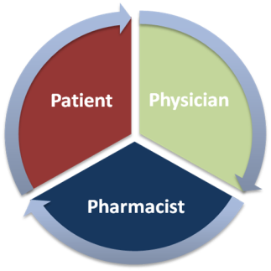

***It is our passion to enhance your patient's quality of life.***

Custom strength medications are unique because your patients are unique. Feel free to contact me directly by phone at **800-547-1399**, or by e-mail at shodges@innovationcompounding.com. You can visit our website at [www.innovationcompounding.com](http://www.innovationcompounding.com), and browse our medication toolkit, the Compounding Compass.

Best Regards,



6095 Pine Mountain Rd, NW Ste 108

Kennesaw, GA 30152

Tel: 800-547-1399

Fax: 770-426-1965

Shawn E. Hodges, PharmD

Innovation Compounding, Inc

**

